NORTHWIND SALES REPORT

Name: PRAMODHINI MJ
Cource: B.COM FINTECH WITH AI
Roll No: E25FA029

Sales Performance Dashboard Using Microsoft Power BI

1. Introduction & Objectives
For this project, I developed an interactive Sales Performance Dashboard using Microsoft Power BI to transform raw and complex sales data into meaningful, easy-to-understand business insights. The main objective of the dashboard is to provide a clear overview of sales performance and help users understand important business metrics through interactive visualizations.
The dashboard focuses on key performance indicators such as total sales, total orders, total quantity sold, total freight costs, average freight, and total customers. It also provides a detailed analysis of sales across different product categories and products.
In addition, the dashboard helps analyze monthly order trends, employee-wise order performance, customer distribution by country, and product-level sales performance. Interactive filters and drill-through functionality were incorporated to allow users to explore the data from different perspectives.
The project demonstrates how Power BI can be used as a business intelligence tool to support data analysis, performance monitoring, trend identification, and informed business decision-making.

2. Dataset & Data Preparation
The project uses a connected dataset containing multiple tables related to customers, employees, products, categories, orders, order details, and shipping partners. These tables provide different types of information required for performing comprehensive sales analysis.
Before developing the dashboard, I imported and organized the data in Power BI. The data preparation process involved understanding the structure of each table, establishing relationships between related tables, checking data consistency, and preparing the dataset for analysis.
The main objective of data preparation was to ensure that the information was properly connected and could be used effectively for calculations, filtering, and visualization.
The data model was structured so that information from orders could be analyzed based on products, categories, customers, employees, countries, and shipping details.

3. About the Data
The project consists of several interconnected tables that provide detailed information about the sales process and business operations.
Categories
- Category ID
- Category Name
- Category Details
Customers
- Customer ID
- Company Name
- Contact Information
- City
- Country
Employees
- Employee ID
- Employee Name
- Job Title
- City
- Country
Orders & Order Details
- Order ID
- Product ID
- Order Date
- Price
- Quantity
- Discount
- Shipping/Freight Cost
Products
- Product ID
- Product Name
- Price
- Category
- Product Status
Shippers
- Shipper ID
- Shipper Company Name
These tables were connected to create a structured data model that allows different dimensions of sales performance to be analyzed together.

4. Data Preparation & Data Modeling
Before creating the dashboard, the dataset was cleaned, organized, and structured in Power BI.
The major data preparation activities included:
- Connecting the Orders table with Order Details.
- Linking products with their respective categories.
- Connecting customer information with order transactions.
- Linking employee information to analyze employee-wise performance.
- Connecting shipping information to study freight costs.
- Checking important fields such as price, quantity, discount, order dates, and shipping costs.
- Establishing appropriate relationships between the tables.
- Checking the data for consistency and accuracy.
- Creating calculated measures using DAX (Data Analysis Expressions).
- Preparing the data model so that slicers and visualizations interact correctly.
Proper data modeling helped ensure that the dashboard produced accurate results when users applied different filters or explored individual categories and countries.

5. Dashboard Components
The dashboard was designed to provide a clear and interactive view of overall sales performance. I used different types of Power BI visuals to present the information in a simple and meaningful way.
The dashboard contains KPI cards, line charts, column charts, bar charts, tables, slicers, and drill-through functionality.
The summary cards provide an immediate overview of important business metrics, including:
- Total Orders – 809
- Total Quantity Sold – 51K
- Total Freight/Shipping Cost
- Number of Customers – 91
The dashboard also contains a line chart to analyze order trends over different months. This helps users understand changes in order activity throughout the year.
A column chart was used to compare sales across different product categories, such as Beverages, Dairy, and other product categories.
A bar chart was created to analyze the number of orders handled by individual employees. This allows users to compare employee-wise order activity.
Another bar chart displays the distribution of customers across different countries, including countries such as the USA, France, and Germany.
A detailed product table was also included to provide a more detailed view of individual products, their categories, sales values, and quantities sold.

6. Calculations – DAX Measures
To perform the required business calculations, I created several DAX measures in Power BI.
Total Orders
Calculates the total number of orders placed in the dataset.
Total Freight
Calculates the total shipping or freight cost associated with the orders.
Average Freight
Calculates the average freight cost associated with the orders.
Number of Customers
Calculates the number of customers available in the dataset.
Total Quantity Sold
Calculates the total number of items sold by adding the quantities from the order details.
Total Sales
Calculates the overall sales revenue based on price, quantity, and applicable discounts.
These DAX measures make the dashboard dynamic because the calculated values automatically change when users apply filters or slicers.
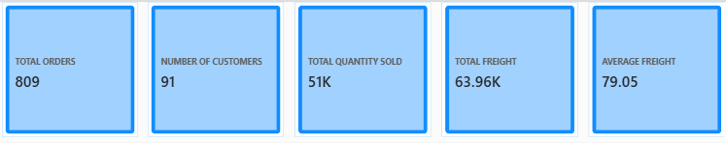

7. Dashboard Features
Summary Cards – KPIs
The dashboard contains KPI cards that provide an instant summary of important business performance indicators.
The major KPIs include:
- Total Orders – 809
- Total Items Sold – 51K
- Total Freight
- Number of Customers – 91
- Total Sales
These KPIs allow users to understand the overall performance without having to examine every individual chart.

Orders by Month
A line chart was used to display the number of orders across different months.
This visualization helps identify changes in order activity over time. Users can observe periods of higher and lower order volumes and understand the overall trend.
It can also help businesses identify seasonal patterns and periods that may require additional attention.

Sales by Product Category
A column chart was created to compare sales performance across different product categories.
Categories such as Beverages, Dairy, and other product groups can be compared based on their sales contribution.
This visualization helps identify categories that generate higher sales and categories that have relatively lower sales performance.

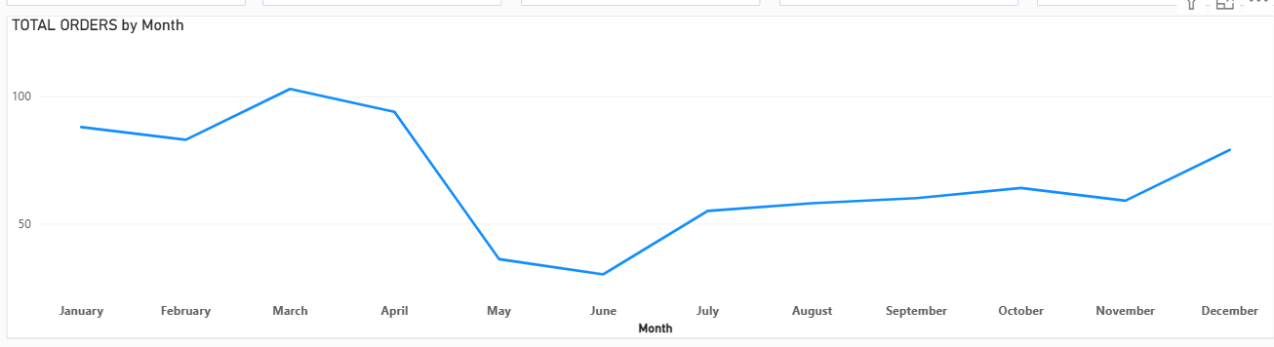

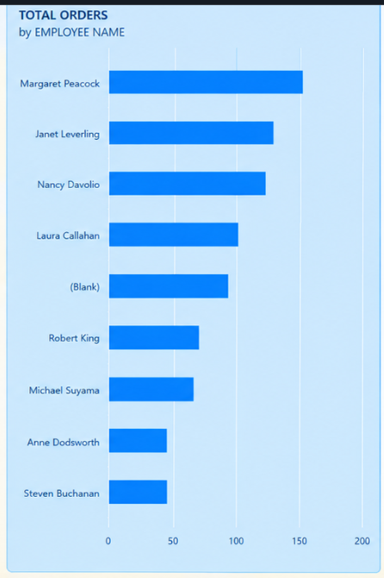

Orders by Employee
A bar chart was used to display the number of orders handled by each employee.
This provides an employee-wise view of order activity and allows users to compare the workload across employees.
The visualization can help management understand the distribution of orders among employees and identify differences in order-handling activity.

Customers by Country
A bar chart was created to analyze the geographical distribution of customers.
Countries such as the USA, France, and Germany can be compared based on customer count.
This helps provide an understanding of the geographical reach of the business and identifies countries with a larger customer base.

Product Details Table
A detailed table was included to provide product-level information.
The table contains information such as:
- Product Name
- Product Category
- Total Sales
- Total Quantity Sold
- Product-related details
This allows users to move from a high-level dashboard view to detailed product information.

8. Interactive Filters – Slicers
To make the dashboard interactive and user-friendly, I added three slicers:
- Year
- Country
- Category
These slicers allow users to dynamically filter the dashboard based on their requirements.
For example, if a user selects a particular country, the charts and tables can update to display information related to that country.
Similarly, selecting a specific year or product category allows users to focus on a particular period or product group.
The slicers improve the usability of the dashboard because users can explore different combinations of data without manually changing individual charts.
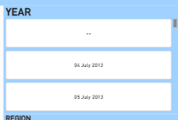
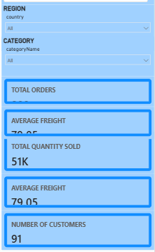

9. Drill-Through Functionality
I also implemented Drill-Through functionality in Power BI to allow users to move from a summarized view to a more detailed analysis page.
Drill-through enables users to select a particular data point, such as a product, category, employee, or other relevant field, and navigate to another page containing detailed information related to that selection.
This feature improves the analytical capability of the dashboard by allowing users to move from high-level information to detailed information.
For example, a user can select a specific category or product from the main dashboard and view its related details on the drill-through page.

10. Interactive Dashboard Experience
The dashboard was designed to provide an interactive analytical experience rather than simply displaying static information.
Users can interact with different charts, slicers, tables, and drill-through options to explore the dataset.
When a user selects a particular value in a visual, related visuals can respond accordingly based on the relationships and filters in the Power BI data model.
This interactive functionality makes it easier to identify patterns, compare business performance, and investigate specific areas of interest.

11. Key Insights from the Dashboard
The dashboard provides several useful insights into the sales data.
- The business recorded 809 total orders.
- Approximately 51K items were sold.
- The dashboard contains information for 91 customers.
- Sales performance can be compared across multiple product categories.
- Monthly order trends can be analyzed to identify changes in demand.
- Employee-wise order activity can be compared using the employee chart.
- Customer distribution can be analyzed across different countries.
- Product-level performance can be examined using the detailed product table.
- Freight costs can be analyzed using total and average freight measures.
- Interactive filtering makes it possible to analyze performance for specific years, countries, and categories.

12. Tools & Technologies Used
Microsoft Power BI
Used for data visualization, dashboard development, interactive reporting, and business analysis.
Power Query
Used for importing, cleaning, transforming, and preparing the data.
DAX
Used to create calculated measures and perform business calculations such as total sales, total orders, quantity sold, and freight analysis.
Data Modeling
Used to establish relationships between different tables and create an effective analytical data structure.
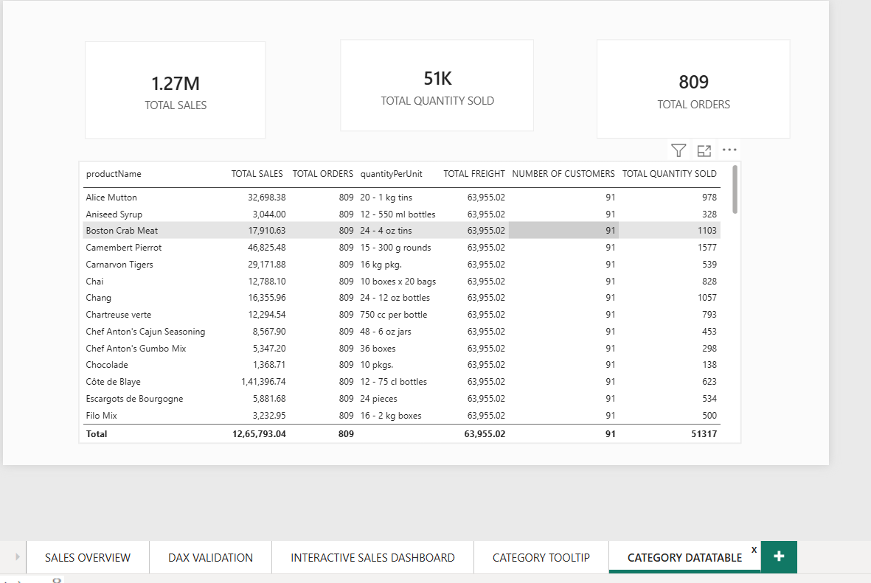

13. Skills Demonstrated
Through this project, I developed and demonstrated the following skills:
- Microsoft Power BI
- Data Cleaning
- Data Transformation
- Data Modeling
- DAX Measures
- KPI Development
- Data Visualization
- Business Intelligence
- Interactive Dashboard Development
- Slicers and Filters
- Drill-Through Reports
- Sales Performance Analysis
- Customer Analysis
- Employee Performance Analysis
- Product and Category Analysis
- Business Data Interpretation

14. Conclusion
Overall, this project provided practical experience in using Microsoft Power BI to convert raw business data into meaningful and interactive insights. By combining data preparation, data modeling, DAX calculations, and different visualization techniques, I developed a dashboard that presents sales performance in a clear and structured manner.
The dashboard provides a comprehensive view of orders, sales, quantity sold, freight costs, customers, employees, products, categories, and geographical distribution. The use of KPI cards provides a quick overview of business performance, while charts and tables allow users to perform deeper analysis.
The implementation of Year, Country, and Category slicers makes the dashboard interactive and allows users to analyze specific portions of the dataset. The addition of Drill-Through functionality further improves the dashboard by allowing users to move from summarized information to detailed analysis.
This project strengthened my practical understanding of Business Intelligence, Power BI, DAX, data modeling, data visualization, and business analytics. It also helped me understand how organizations can use data-driven dashboards to monitor performance, identify trends, compare business activities, and support more informed decision-making.

